Proctor Exams Recording Tool Installation Instructions for Mac users

- Click on Download the Proctor Exams Recording Tool for Mac and execute ProctorRecToolMac.dmg

2. Drag the Proctor Exam Tool.app to the Applications folder

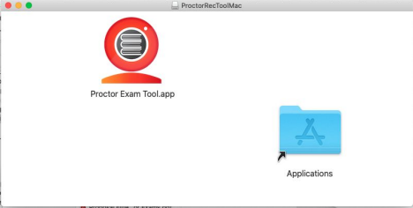

- On the Applications, execute the Proctor Exam Tool

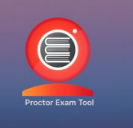

4. When getting this prompt, click on Cancel

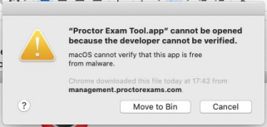

5. Go to System → Security & Privacy, on the General tab

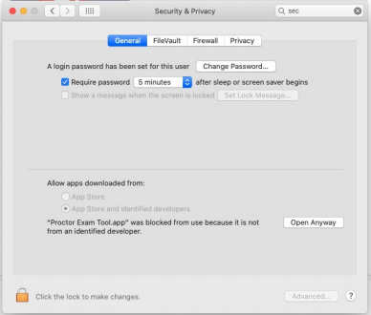
6. Click on the lock to be able to perform changes
7. Click on Open Anyway

8. On the next prompt, click on Open

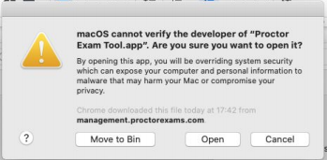

9. When the application opens, enter the username you copied at the beginning of the process and click on Login to ProctorExam.com.

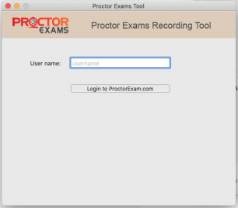

10. Allow the application to access the camera

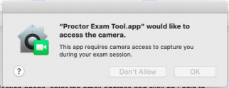

Please contact us at customersupport@proctorexams.com or 855-577-6286, ext. 2 for further assistance.

